**A1**

**Look at the picture and answer the questions below.**

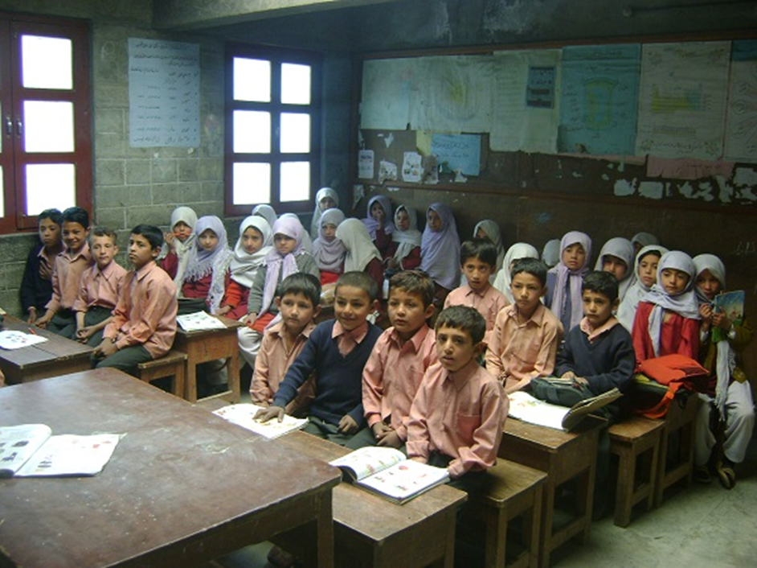

1. Describe the picture. (Who? What? When? Where?)
2. How do these people feel? Why do you think so? What were they doing before the photo was taken? What are they going to do next?

**A2**

**Look at the picture and answer the questions below.**

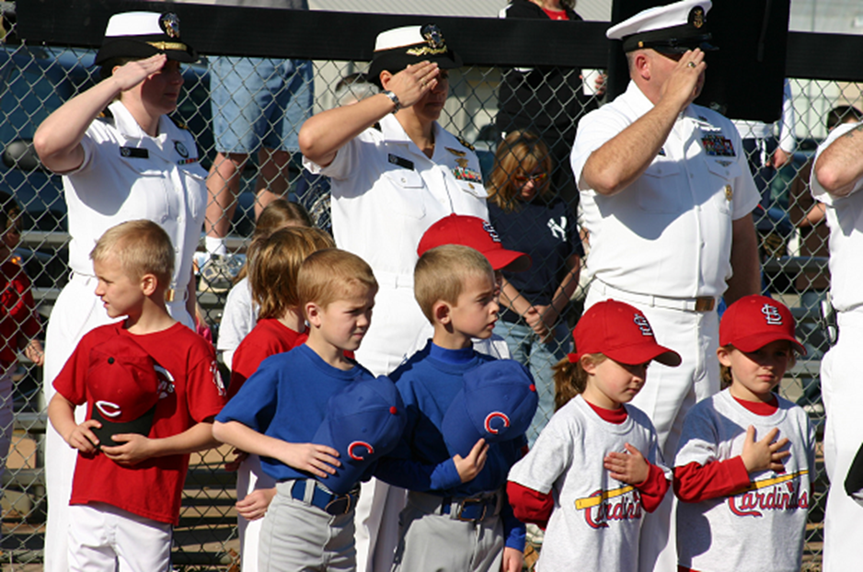

1. Describe the picture. (Who? What? When? Where?)
2. How do these people feel? Why do you think so? What were they doing before the photo was taken? What are they going to do next?

**A3**

**Look at the picture and answer the questions below.**



1. Describe the picture. (Who? What? When? Where?)
2. How do these people feel? Why do you think so? What were they doing before the photo was taken? What are they going to do next?

**A4**

**Look at the picture and answer the questions below.**

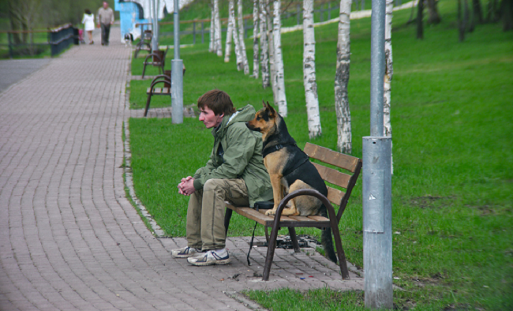

1. Describe the picture. (Who? What? When? Where?)
2. How does this person feel? Why do you think so? What were he and the dog doing before the photo was taken? What are they going to do next?

**A5**

**Look at the picture and answer the questions below.**

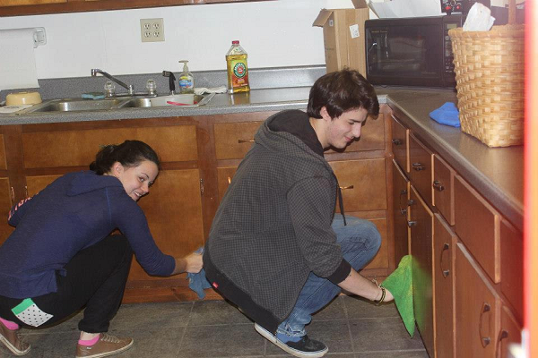

1. Describe the picture. (Who? What? When? Where?)
2. How do these people feel? Why do you think so? What were they doing before the photo was taken? What are they going to do next?

**A6**

**Look at the picture and answer the questions below.**

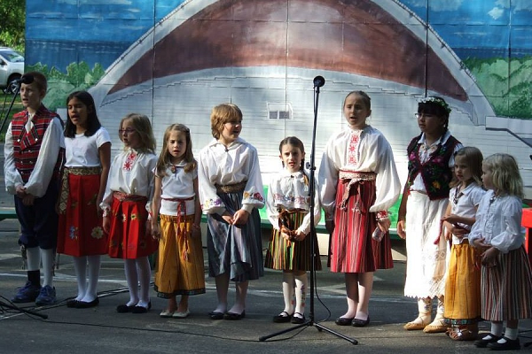

1. Describe the picture. (Who? What? When? Where?)
2. How do these people feel? Why do you think so? What were they doing before the photo was taken? What are they going to do next?