CLASS EXCURSION A1
1) Discuss both options and suggest both.

2) Agree with your teacher’s suggestion.
3) Discuss both options and suggest one.
4) Agree with your teacher’s suggestion. Give reasons.
5) Discuss both options and suggest both.
6) Agree with your teacher’s suggestion.
7) Summarise your decision.
INTERNATIONAL EVENT A2
1) Discuss both options and suggest one.

2) Disagree with your teacher’s suggestion. Give reasons.
3) Suggest both options and give reasons.
4) Agree with your teacher’s suggestion. Give reasons.
5) Discuss both options and suggest one.
6) Agree with your teacher’s suggestion.
7) Summarise your decision.

SURPRISE BIRTHDAY PARTY A3
1) Discuss both options and suggest one. | 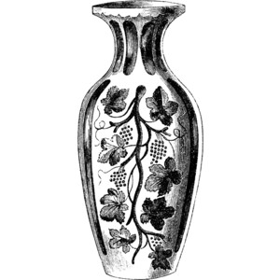 | 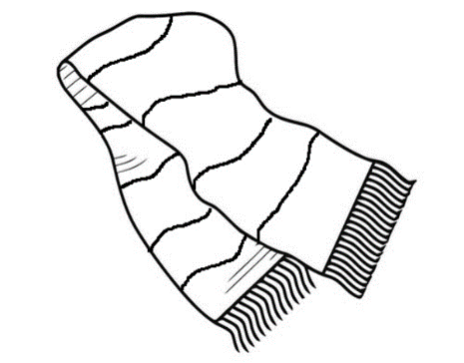
2) Disagree with your teacher’s suggestion. Give reasons.
3) Discuss both options and suggest one.
4) Agree with your teacher’s suggestion.
5) Discuss both options and suggest one.
6) Agree with your teacher’s suggestion.
7) Summarise your decision.
TRIP TO NATURE A4
1) Discuss both and suggest one.

2) Disagree with your teacher’s suggestion. Give reasons.
3) Suggest both options and give reasons.
4) Agree with your teacher’s suggestion.
5) Discuss both and suggest one.
6) Agree with your teacher’s suggestion.
7) Summarise your decision.

CLEANING DAY A5
1) Discuss both options and suggest both. | 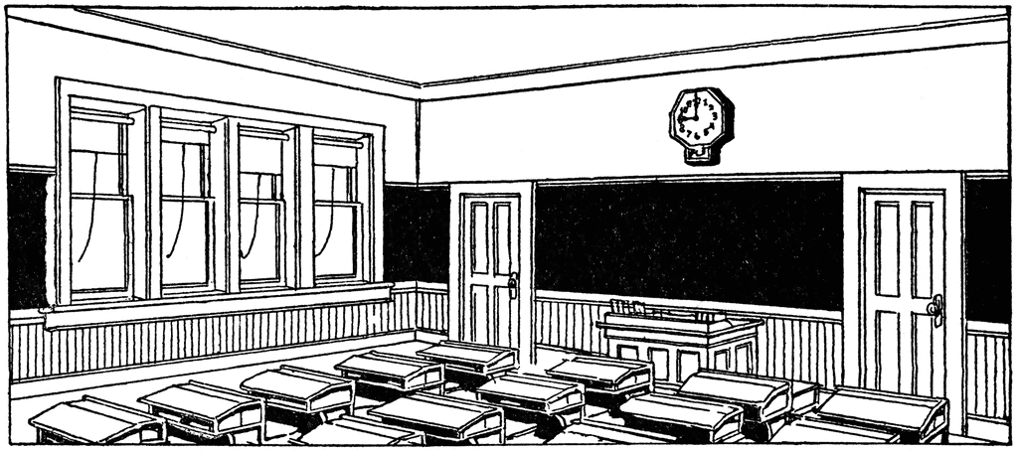
2) Agree with your teacher’s suggestion.
3) Discuss both and suggest one.
4) Disagree with your teacher’s suggestion. Give reasons.
5) Discuss both options and suggest both.
6) Agree with your teacher’s suggestion.
7) Summarise your decision.

FOREIGN SCHOOL VISIT A6
1) Discuss both options and suggest one.

2) Disagree with your teacher’s suggestion. Give reasons.
3) Discuss both options and suggest one. |  | 
4) Agree with your teacher’s suggestion.
5) Suggest both options and give reasons.
6) Agree with your teacher’s suggestion.
7) Summarise your decision.

