Stage 2: Task 1 (max 7–8 minutes) LEARNING AND WORKING A1
[Allow 3 minutes of uninterrupted preparation time. The recorder must NOT be switched off during that time.]
Student card
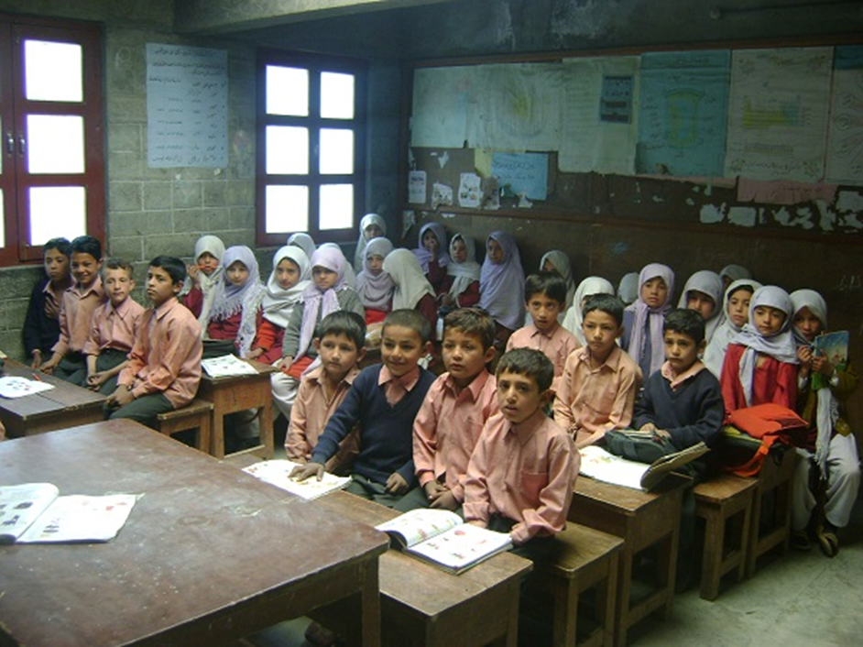
- Describe the picture. (Who? What? When? Where?)
- How do these people feel? Why do you think so? What were they doing before the photo was taken? What are they going to do next?
Alright. Remember, you have 2 minutes for this, so I will stop you when the time is up. Please start speaking now.
[Allow 2 minutes of uninterrupted speaking time.]
[When the student has been speaking for 2 minutes, find a logical place (end of a sentence or thought) to stop the student.]
OR
[When the student has spoken for less than 2 minutes or it is not clear if he/she has finished, ask ‘Is that all you wanted to say?’]
Thank you. Now I would like you to answer some questions.
1) What was the most difficult thing for you when you went to school as a child? Why?
2) Do you think everyone should learn a skill in a vocational school? Why? /Why not?
3) Will online learning replace learning in a classroom in the future? Why? /Why not?
4) Which is better – a small country school or a big city school? Explain.

Thank you. Let’s go on to task 2.
STAGE 3: Task 2 (max 3 minutes) A1
In this task, we’re going to act out a situation.
We are going to make plans for a class trip. Here is a card with pictures and prompts that should help you. You now have a minute to think about the situation. I will start the conversation.
[Allow 1 minute of uninterrupted preparation time.]
1) Alright, let’s talk about it. Where should we go?

Student discusses both options and suggests both.

2) Good idea. Maybe we should also find a place to eat lunch? (Student agrees.)

3) OK. Where should we go?

Student discusses both options and suggests one.
4) Good idea. I think you should ask your classmates’ opinion. (Student agrees and gives reasons.)

5) OK. Is there anything else we should tell the students about?

Student discusses both options
and suggests both.
6) That’s not a bad idea. Maybe we should discuss it with everyone else?
(Student agrees.)

7) OK. So, what did we agree on?

8) That sounds like a plan.

Thank you. This is the end of the interview.
[Switch off the recorder.]
[Before the student leaves the room
• tell the student when the scores will be announced
• collect the student’s notes]

Stage 2: Task 1 (max 7–8 minutes) COUNTRIES AND THEIR CULTURES A2
[Allow 3 minutes of uninterrupted preparation time. The recorder must NOT be switched off during that time.]
Student card

- Describe the picture. (Who? What? When? Where?)
- How do these people feel? Why do you think so? What were they doing before the photo was taken? What are they going to do next?
Alright. Remember, you have 2 minutes for this, so I will stop you when the time is up. Please start speaking now.
[Allow 2 minutes of uninterrupted speaking time.]
[When the student has been speaking for 2 minutes, find a logical place (end of a sentence or thought) to stop the student.]
OR
[When the student has spoken for less than 2 minutes or it is not clear if he/she has finished, ask ‘Is that all you wanted to say?’]

Thank you. Now I would like you to answer some questions.
1) Did you take part in any Estonian cultural activities when you were a child? Explain.
2) Is learning about foreign cultures important? Why? /Why not?
3) Will people travel more or less in the future? Why?
4) Which is better – living in a small country or a big country? Explain.

Thank you. Let’s go on to task 2.

STAGE 3: Task 2 (max 3 minutes) A2
In this task, we’re going to act out a situation.
We are having an international event at our school. We’re going to make plans for it. Here is a card with pictures and prompts that should help you. You now have a minute to think about the situation. I will start the conversation.
[Allow 1 minute of uninterrupted preparation time.]
1) Alright, let’s talk about it. What kind of activities should we have?
Student discusses both options and suggests one.

2) Interesting idea, but what do you think about a talk from a foreigner? (Student disagrees.)
3) Yes, I think you’re right. Let’s do what you suggested. What kind of food should we serve?
Student suggests both and gives reasons.
4) That’s a good idea. Maybe we could also find a restaurant to sponsor the event?
(Student agrees and gives reasons.)
5) OK. What would be the best time to have the event?
Student discusses both options and suggests one.

6) That’s not a bad idea. Maybe we could also put up posters in the school? (Student agrees.)
7) OK. So, what did we agree on?
8) That sounds like a plan.
Thank you. This is the end of the interview.
[Switch off the recorder.]
[Before the student leaves the room
• tell the student when the scores will be announced
• collect the student’s notes]
Stage 2: Task 1 (max 7–8 minutes) SPARE TIME A3
[Allow 3 minutes of uninterrupted preparation time. The recorder must NOT be switched off during that time.]
Student card

- Describe the picture. (Who? What? When? Where?)
- How do these people feel? Why do you think so? What were they doing before the photo was taken? What are they going to do next?
Alright. Remember, you have 2 minutes for this, so I will stop you when the time is up. Please start speaking now.
[Allow 2 minutes of uninterrupted speaking time.]
[When the student has been speaking for 2 minutes, find a logical place (end of a sentence or thought) to stop the student.]
OR
[When the student has spoken for less than 2 minutes or it is not clear if he/she has finished, ask ‘Is that all you wanted to say?’]
Thank you. Now I would like you to answer some questions.

1) Did you collect anything when you were a child? Why? /Why not?
2) What is the most popular hobby among your classmates? Explain.
3) Will people have more time for hobbies in the future? Why? / Why not?
4) Is it better to collect things that are valuable or things that you enjoy? Explain.

Thank you. Let’s go on to task 2.
STAGE 3: Task 2 (max 3 minutes) A3
In this task, we’re going to act out a situation.

We are going to plan a surprise birthday party for your teacher. Here is a card with pictures and prompts that should help you. You now have a minute to think about the situation. I will start the conversation.
[Allow 1 minute of uninterrupted preparation time.]
1) Alright, let’s talk about it. What kind of gift should we buy for your teacher?
Student discusses both options and suggests one. | 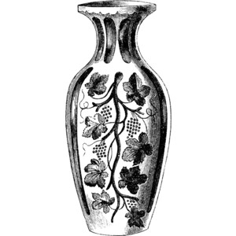 | 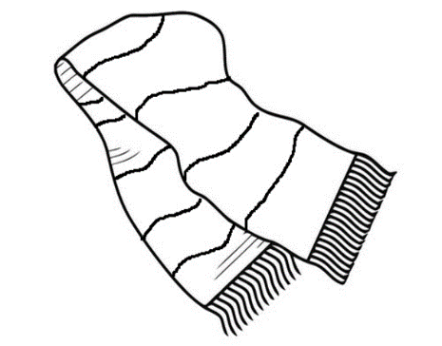
2) Good idea, but what do you think about a pen? (Student disagrees and gives reasons.)
3) Yes, I think you’re right. Let’s do what you suggested. When would be a good time for the party?
Student discusses both options and suggests one.
4) Good idea. Shall we all meet in the classroom 10 minutes before? (Student agrees.)
5) OK. Is there anything else we should discuss?
Student discusses both options and suggests one.
6) That’s not a bad idea. Maybe we should get a card, too?
(Student agrees.)
7) OK. So, what did we agree on?
8) That sounds like a plan.
Thank you. This is the end of the interview.
[Switch off the recorder.]
[Before the student leaves the room
• tell the student when the scores will be announced
• collect the student’s notes]
Stage 2: Task 1 (max 7–8 minutes) ME AND OTHERS A4
[Allow 3 minutes of uninterrupted preparation time. The recorder must NOT be switched off during that time.]
Student card
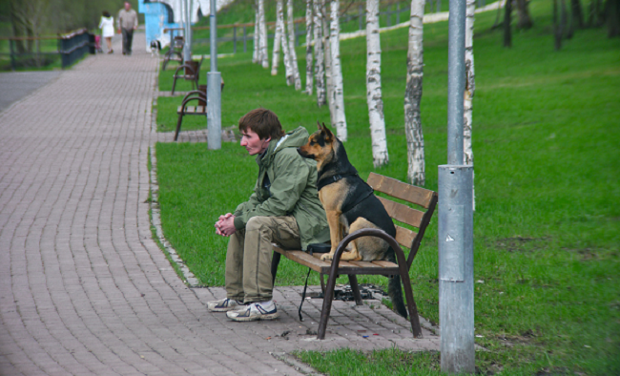
- Describe the picture. (Who? What? When? Where?)
- How does this person feel? Why do you think so? What were he and the dog doing before the photo was taken? What are they going to do next?
Alright. Remember, you have 2 minutes for this, so I will stop you when the time is up. Please start speaking now.
[Allow 2 minutes of uninterrupted speaking time.]
[When the student has been speaking for 2 minutes, find a logical place (end of a sentence or thought) to stop the student.]
OR
[When the student has spoken for less than 2 minutes or it is not clear if he/she has finished, ask ‘Is that all you wanted to say?’]

Thank you. Now I would like you to answer some questions.

1) Did you often spend time alone when you were a child? Why/Why not?
2) Who do you usually turn to if you need advice? Why?
3) Will people spend more time alone in the future? Why?
4) Is it better to be a good listener or a good talker? Explain.

Thank you. Let’s go on to task 2.

STAGE 3: Task 2 (max 3 minutes) A4
In this task, we’re going to act out a situation.

We are going to make plans for a day outdoors. Here is a card with pictures and prompts that should help you. You now have a minute to think about the situation. I will start the conversation.
[Allow 1 minute of uninterrupted preparation time.]
1) Alright, let’s talk about it. What kind of activities should we do?
Student discusses both options and suggests one.

2) Interesting idea, but what do you think about picking berries and mushrooms? (Student disagrees and gives reasons.)
3) OK. Let’s do what you suggested. What kind of things should we take?
Student suggests both and gives reasons.
4) That’s a good idea. Maybe we should also take a compass? (Student agrees.)
5) OK. What about food?
Student discusses both options and suggests one.

6) Yes, I agree. I think we should also take enough water. (Student agrees.)
7) OK. So, what did we agree on?
8) That sounds like a plan.
Thank you. This is the end of the interview.
[Switch off the recorder.]
[Before the student leaves the room
• tell the student when the scores will be announced
• collect the student’s notes]
Stage 2: Task 1 (max 7–8 minutes) MY HOME AND SURROUNDINGS A5
[Allow 3 minutes of uninterrupted preparation time. The recorder must NOT be switched off during that time.]
Student card
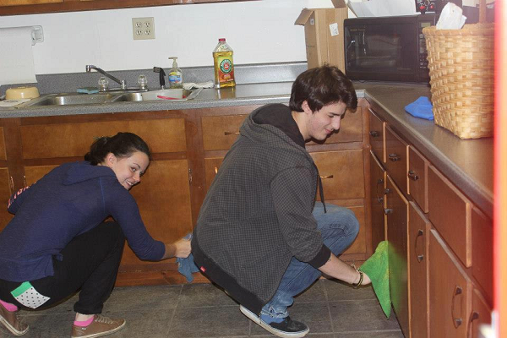
- Describe the picture. (Who? What? When? Where?)
- How do these people feel? Why do you think so? What were they doing before the photo was taken? What are they going to do next?
Alright. Remember, you have 2 minutes for this, so I will stop you when the time is up. Please start speaking now.
[Allow 2 minutes of uninterrupted speaking time.]
[When the student has been speaking for 2 minutes, find a logical place (end of a sentence or thought) to stop the student.]
OR
[When the student has spoken for less than 2 minutes or it is not clear if he/she has finished, ask ‘Is that all you wanted to say?’]
Thank you. Now I would like you to answer some questions.
1) What kind of chores did you do when you were younger? Explain.
2) Do young people do a lot of work around the house today? Why/Why not?
3) Do you think homes will be smaller or bigger in the future? Why?
4) Is it better to do housework alone or with someone else? Explain.

Thank you. Let’s go on to task 2.
STAGE 3: Task 2 (max 3 minutes) A5
In this task, we’re going to act out a situation.
There is going to be a cleaning day. We’re going to make plans for it. Here is a card with pictures and prompts that should help you. You now have a minute to think about the situation. I will start the conversation.
[Allow 1 minute of uninterrupted preparation time.]
1) Alright, let’s talk about it. What do you think needs to be cleaned the most?
Student discusses both options and suggests both. | 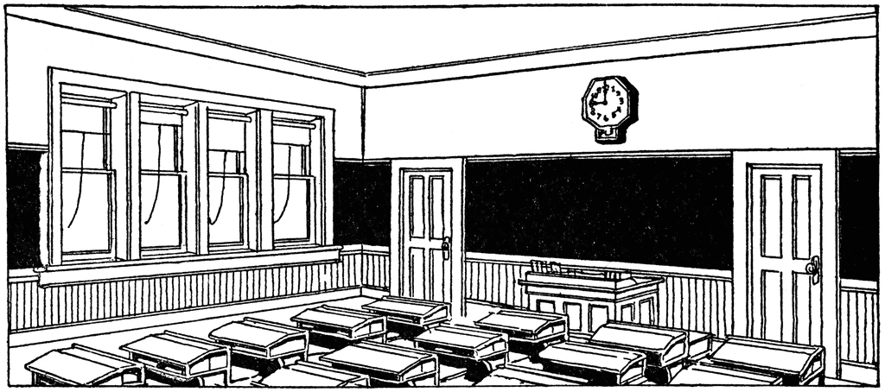
2) That’s a good idea. I think we should clean the sportsground, too. (Student agrees.)
3) OK. What time should we start?
Student discusses both options and suggest one.
4) I think you’re right. What do you think we should do with the things we do not need? How about having an auction? (Student disagrees and gives reasons.)
5) OK, I think you’re right. What should we do with these things then?
Student discusses both options and suggests both.

6) That’s a good idea. Maybe we should also give some things to charity. (Student agrees.)
7) OK. So, what did we agree on?
8) That sounds like a plan.
Thank you. This is the end of the interview.
[Switch off the recorder.]
[Before the student leaves the room
• tell the student when the scores will be announced
• collect the student’s notes]
Stage 2: Task 1 (max 7–8 minutes) ESTONIA — MY HOME A6
[Allow 3 minutes of uninterrupted preparation time. The recorder must NOT be switched off during that time.]
Student card
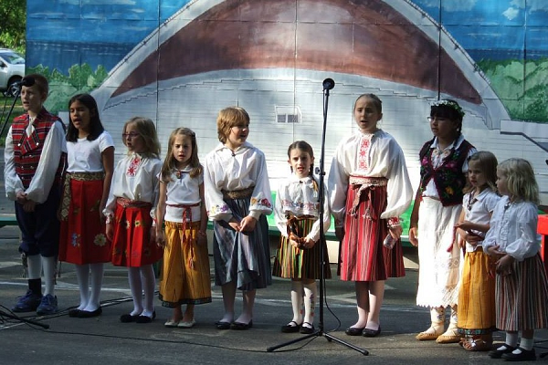
- Describe the picture. (Who? What? When? Where?)
- How do these people feel? Why do you think so? What were they doing before the photo was taken? What are they going to do next?
Alright. Remember, you have 2 minutes for this, so I will stop you when the time is up. Please start speaking now.
[Allow 2 minutes of uninterrupted speaking time.]
[When the student has been speaking for 2 minutes, find a logical place (end of a sentence or thought) to stop the student.]
OR
[When the student has spoken for less than 2 minutes or it is not clear if he/she has finished, ask ‘Is that all you wanted to say?’]
Thank you. Now I would like you to answer some questions.
1) What was your favourite place to visit in Estonia when you were a child? Explain.
2) What places in Estonia are most popular with tourists? Why?
3) Do you think young people will be interested in Estonian traditions in the future? Why? /Why not?
4) Is it better to learn about Estonian traditions from your teachers or family? Explain.

Thank you. Let’s go on to task 2.

STAGE 3: Task 2 (max 3 minutes) A6
In this task, we’re going to act out a situation.

Foreign students and teachers are visiting our school. We’re going to make plans for the event. Here is a card with pictures and prompts that should help you. You now have a minute to think about the situation. I will start the conversation.
[Allow 1 minute of uninterrupted preparation time.]
1) Alright, let’s talk about it. Where shall we take them?
Student discusses both options and suggests one.

2) OK. Should we also take them to the forest? (Student disagrees and gives reasons.)
3) I think you’re right. How will we get around?
Student discusses both options and suggests one. |  | 
4) That’s right. Maybe we should give them transportation timetables? (Student agrees.)
5) OK. What should we suggest they bring?
Student suggests both options and gives reasons.
6) That’s a good idea. I think we should also tell them to bring enough cash. (Student agrees.)
7) OK. So, what did we agree on?
8) That sounds like a plan.
Thank you. This is the end of the interview.
[Switch off the recorder.]
[Before the student leaves the room
• tell the student when the scores will be announced
• collect the student’s notes]

